Brand safety

Brand safety is a major priority for digital marketing teams. Ensuring a brand is in good standing with consumers is important to the heart and the mission of a brand. In this reading, you’ll learn what brand safety means, and how companies execute brand safety.

**What is brand safety?**

Brand safety refers to the practice of keeping a brand's reputation safe when they advertise online. This might mean ensuring the brand’s ads aren’t placed next to or on inappropriate or inaccurate content and making sure no copyrighted materials are used without permission.

If you place ads within the display network, and those ads appear on a website that is spreading misinformation, your brand may be damaged because you are automatically associated with brands that are pushing inaccurate information. For example, if your brand values inclusivity, you wouldn’t want your brand’s ads to appear on a site that holds hateful or controversial views.

The Interactive Advertising Bureau (IAB) has designated 13 topics that brands should avoid associating themselves with to maintain brand safety. Those are: military conflict, obscenity, drugs, tobacco, adult content, arms, crime, death/injury, online piracy, hate speech, terrorism, spam, and fake news. In addition to those, your brand might want to stay away from other topics. For instance, if your brand sells baby toys, you probably don’t want to appear on gambling sites.

So, as a digital marketer, how do you make sure you’re avoiding being associated with topics you would prefer your brand not be associated with?

**Ensuring brand safety**

As a digital marketer, there are steps you can take to ensure your brand is maintaining brand safety. First, you’ll want to **define what is considered to be “unsafe”** for your brand. Consider what topics might be harmful to your brand. Then, make sure you and your team **understand that scale isn’t everything.** Ending up on every single website on the internet isn’t worth the risk and harm done to your brand safety. Next, **use trusted technology**. When you’re submitting ads to display networks or social media, make sure you’re using brand safety tools to maintain brand safety. For instance, with the Google Display Network, you can opt-out of specific sites that you want to stay away from.

Some strategies marketers take to maintain brand safety are:

* Buy ad space directly from reputable publishers. This will ensure your ads aren’t placed where you don’t want them.
  + **Note:** doing this may mean you miss out on potential sales since you’re limiting yourself to certain customers.
* Use image recognition. This will identify images that deem content unsafe for your brand.
* Select keywords to avoid. Publishers will allow you to choose keywords to avoid, so you can include those when you submit your content.
* Apply geotargeting. This means making sure you know which regions your ads are running in, which helps you make sure you are remaining sensitive and relevant to all your customers.

**Key takeaways**

Because it’s so integral to your brand’s success, brand safety is a topic that takes a lot of careful consideration. Make sure you know what types of topics and content you don’t want your brand associated with, and then take action. After you’ve carefully considered how to maintain brand safety, publishers and tools will help you take your brand safety measures to the next level.

**Resources for more information**

The following resources can help you maintain brand safety if you’re using them to publish your ads:

* [Facebook brand safety controls](https://www.facebook.com/business/help/1926878614264962?id=1769156093197771)
* [Google Display & Video 360 help: Brand safety targeting](https://support.google.com/displayvideo/answer/3032915)

Mark as completed

Like

Dislike

Report an issue

Lately, you have focused on brands and why they are valuable for digital marketing. You learned that a brand is the foundation of a digital marketing strategy and guides all of a company’s marketing and sales efforts. Brand success is essential to the success of a company.

Consider what you have learned about brands, and then analyze a brand you consider successful. The brand may be one you learned about in this course or one that you find online.

For this discussion prompt, write one to two paragraphs (100–200 words) about:

* Which brand you selected
* Why you chose this brand
* What makes the brand equity positive
* How you would describe the brand’s value system
* The key characteristics that make this brand successful

Then, visit the discussion forums to check out what others shared, and choose two posts to comment on and discuss.

Participation is optional

Find your audience and understand your customers

In this reading, you will learn about creating customer personas to reach your intended audience. By analyzing certain customer data points, you will be able to determine the type of content your audience engages with.

**Why is it important to know your audience?**

When you identify your audience, you can create digital marketing campaigns that interest and engage them. This can lead to brand growth and increased awareness.

Knowing your audience involves learning details about their lives, such as their geographic location, interests, online activities, and preferences. It’s important to understand what content your audience likes and how they like to consume it. For example, do they enjoy receiving humorous content via email? Maybe they like to be introduced to new products via social media ads. Perhaps they are more likely to engage with an ad if they see it while they’re on a website they frequently visit. There is a lot to consider when you are thinking about your audience, but start by learning who they are.

**Who is your audience?**

**Understanding customer personas**

**Customer personas** represent a group of similar people in a desirable audience. They are profiles of your likely customers, based on data and research. Creating customer personas can help a company figure out how to reach people at the right time and with the right message, offer, or products. Personas allow you to focus your time and energy on prospective leads that may actually turn into customers, rather than random people who may not have any interest in your company at all.

There are a few ways to create customer personas. Marketing automation tools like HubSpot, Xtensio, and Up Close & Persona have persona generators built in. However, if you prefer to create your own, you will need to conduct some research.

**Asking the right questions**

Using surveys, interviews, and/or data that already exists in your automation tools, you can find the information needed to create your personas. That information will most likely be demographics like gender, age, geographical location, income, education, and job type.

If you collect this information through surveys or interviews, it’s important you ask questions based on your business’ goals. Sometimes, it’s as simple as finding out your customers’ personality traits, hobbies, and which social media platforms they use to engage with brands.

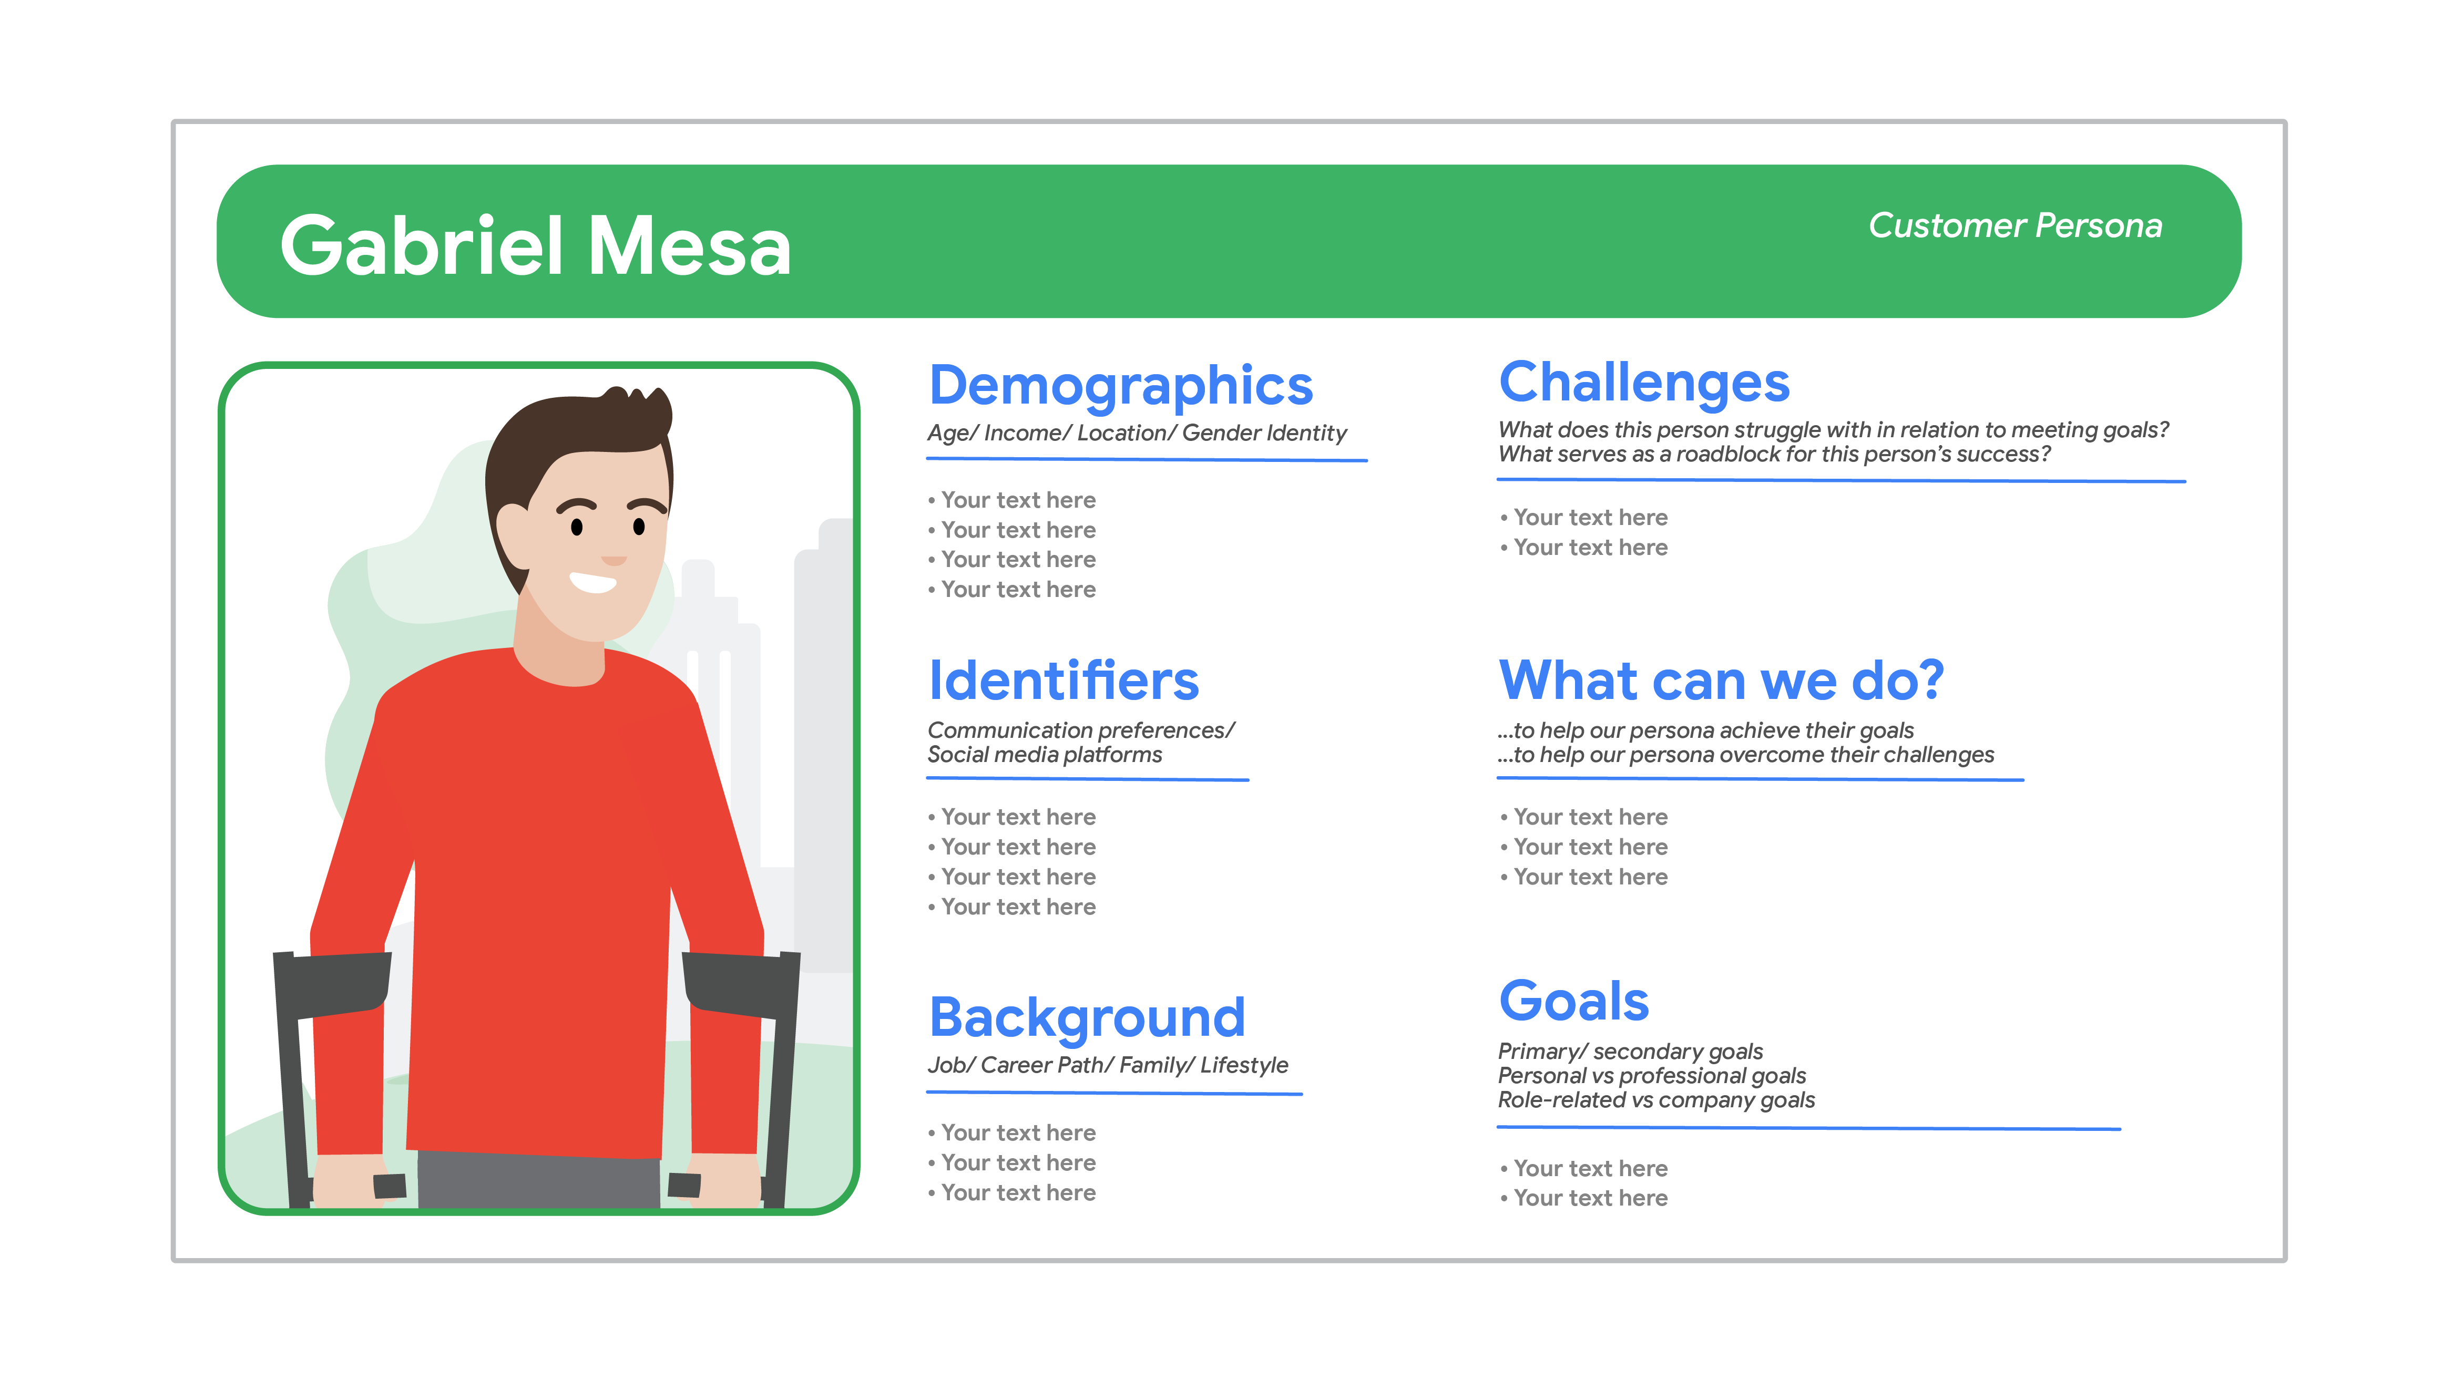

***Note****: Your customer personas may not look exactly like this. They may be more or less detailed or include different information. It’s all about what is right for your company. You will get more in-depth instructions on how to create customer personas in a later reading.*

**Key takeaways**

**Customer personas** represent a group of similar people in a desirable audience. They:

* help a company figure out how to reach people at the right time and with the right message, offer, or products
* allow you to focus your time and energy on prospective leads that may actually turn into customers
* can be created manually or using automated tools

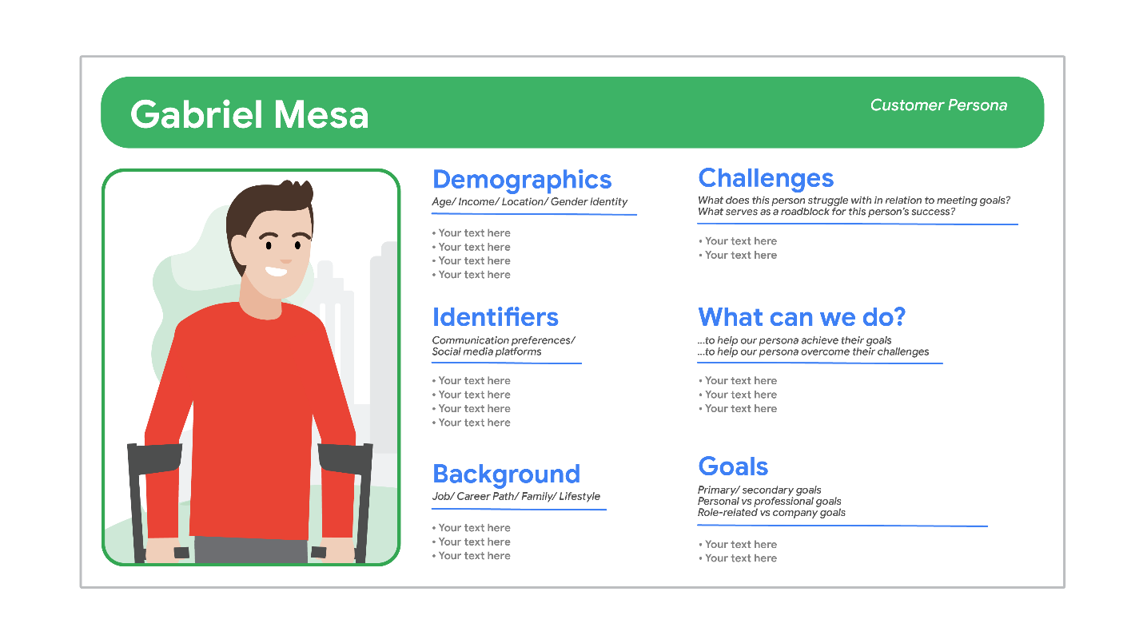

How to set SMART goals

Throughout this program, you will learn about **SMART goals**. In this reading, you will gain a very broad understanding of what SMART goals are. Later in the course, you will build on that understanding with more in-depth readings, videos, and activities.

**What are SMART goals?**

Before you create marketing campaigns, you need to evaluate what your company’s goals are. You may want to boost brand awareness, increase customer satisfaction, or increase conversions, but those hopes aren’t necessarily your goals yet. For them to be goals, they need some additional details and specifications.

When you set your goals, you’ll want to refer to the acronym SMART. SMART stands for **specific, measurable, attainable, relevant,** and **time-bound.** Ensuring your goals meet this criteria will help keep you organized, give you a sense of direction as you move through your campaigns, and provide you with a time frame to work within.

**SMART considerations**

To make sure your goals are SMART, consider the following factors:

* **Specific**: What do you want to accomplish?
* **Measurable**: What are the success metrics that will determine whether the objective has been met?
* **Attainable**: Is this a realistic goal that you think you can meet?
* **Relevant**: Is this specific marketing goal aligned with your company’s overall objectives?
* **Time-bound**: What is a realistic time frame that this goal can be met within?

**Example scenario**

You’re a digital marketer for a photography and photo sharing company. Users can upload their photos onto your website and, using your design templates, make scrapbooks and other items to commemorate events, trips, loved ones, and more. You are setting new SMART goals in preparation for the upcoming financial quarter.

You know the company wants to focus on increasing scrapbook sales for this next quarter, so you start thinking about goals. You decide to set a SMART goal to give you something to compare your progress against. You come up with:

*We aim to increase scrapbook sales by 15% by the end of the next quarter through a robust social media campaign where we focus heavily on influencer marketing.*

This goal fits all of the SMART goal criteria, which means you’ll be able to easily track your progress and make adjustments as the social media campaign progresses.

**Key takeaways**

This is just the beginning of your journey in learning more about setting SMART goals. As you move along in the course, you’ll gain some additional context for your SMART goals. For now, remember that SMART goals should always be: **specific, measurable, attainable, relevant,** and **time-bound.**

Mark as completed

Like

Dislike

Report an issue

# Display advertising

The purpose of this reading is to introduce you to a common type of advertising: display advertising. Display advertising is used by millions of companies around the world because of its effectiveness.

**What is display advertising?**

**Display ads** are visual ad formats placed on webpages or apps. Display ads are images, text, videos, or GIFs that are submitted to display networks and then placed in front of your ideal audience to promote your brand, service, or product.

A **display network** is a group of websites, videos, and apps where your ads can appear. Some display networks may include up to two million websites. Display networks allow marketers to target ads to particular audiences, contexts, locations, and more. Some examples of display networks are the Google Display Network, Taboola, and Criteo. However, there are many options, and we encourage you to research as many as you can in order to determine which is best for your company.

There are also **ad exchanges**, digital marketplaces where buyers and sellers come together and enter into a real-time bidding process to buy and sell ad space. Ad exchanges pool ad inventory from multiple publishers and display networks. Agencies and advertisers typically bid on impressions from ad exchanges via a tool called a demand-side platform. Xandr, OpenX, Magnite, Pubmatic, and Google Ad Manager are examples of ad exchanges.

**Types of display ads**

* **Image ads** are static JPG, PNG, or animated GIF files that appear on websites. Reaching customers through visuals is an effective approach because users can see the usefulness of your product.
* **Text ads** are general ads that appear on websites as text only. These aren’t the most dynamic ads, since they are text only.
* **Responsive ads** automatically adjust their size and format to fit the available space around them. The flexibility and capability of responsive ads makes them very popular. They can also appear as native ads, which means they are designed and formatted to look like a native piece of the website’s content.
* **App promotion ads** are ads that drive app downloads and engagement from users by getting them to download apps. App promotion ads are great because when clicked, they send users straight to their app store to easily get whatever app your company wants them to download. These ads will only appear on devices compatible with your content.

**How do display ads fit into the marketing funnel?**

As you create digital marketing campaigns and aim to introduce your company and engage with potential customers, you may opt into using display ads to ensure an effective and successful marketing strategy. At Google, display ads are employed during the awareness and consideration buckets of the funnel because of the potential to drive awareness and increase the customer base. However, we also enlist display ads further down the funnel to remarket. Remarketing delivers paid ads to customers who have visited your website or social media profile. This helps increase conversions and keep loyal customers.

Mark as completed

Like

Dislike

Report an issue

# Choose the right platforms for your target audience

Even if you have used social media platforms personally, it’s important to understand that using them as a digital marketer is very different. This reading will introduce how to set and achieve goals using specific social media tools and platforms.

### ****Goal 1: Build connections with your audience****

One goal of brands is to build relationships with their audience. If your brand or business has chosen to prioritize this as a goal or objective, you will want to consider which social media platforms are best for relationship building. For example, interactive, word-based platforms where people interact in short messages and where open communication is encouraged—like Twitter—are well suited to relationship building. This is because the art of conversation is so encouraged and prioritized on Twitter. It is perhaps one of the only platforms where a brand may post dozens of times a day, without overloading its followers.

To build relationships with your audience on a platform like Twitter, you will want to be responsive and engaging. If someone is interacting with your brand, feel free to reply promptly and keep the conversation going. If they are mentioning you because of an issue with an order, provide them with helpful, empathetic, and supportive customer service. Possibly the most important thing to remember while engaging with users online is to always make sure you are being authentic to your brand’s voice. Your followers will come to expect a certain voice, and they will recognize you for it.

**Pro tip:** Sometimes, it’s best to be proactive about relationship building. Instead of waiting for users to reach out to you, actively seek out authentic connections and communication within your community of followers.

### ****Goal 2: Target new customers****

If your goal is to target new customers, you may find some success on an image-based photo and video sharing platform like Instagram. This is a good place to show people your product, rather than telling them about it. To target new customers, it is a good idea to tell your brand’s and products’ stories using interesting and dynamic visuals.

Instagram is effective for telling your brand’s story because its users spend significant time on the platform learning, being inspired, shopping, testing new things out, and so much more. And, it is a unique platform because brands can leverage other users with large followings to tell their story as well.

For example, leveraging a strategy like influencer marketing is an effective tactic to target new customers. **Influencer marketing** involves a brand collaborating with an online influencer to market one of its products or services. When an influencer introduces your brand to their followers—a group of people who may not know about you yet—this can be really helpful for targeting new customers. Another example of an effective strategy is running social media ad campaigns, where your brand’s reach is sure to increase.

**Pro tip:** If you prioritize influencer marketing, make sure your partners have audiences that will be interested in your product once introduced to it.

### ****Goal 3: Drive traffic to your website****

If you want to drive traffic to your website, consider a social media platform that allows you to share articles, links, products, images, and reviews, like Facebook. If the content you are sharing feels fresh, informative, and links back to your landing page, users will be more likely to click on it and end up on your webpage. If users like what they see on your page, they may share your content themselves, possibly resulting in even more website traffic.

When using a platform like this, it’s especially important to couple your brand’s voice and visuals together in a cohesive way. Your content all needs to feel purposeful and relevant, and draw users in, if you want to encourage website visitors.

**Pro tip:** Not all social media platforms allow you to easily share links to landing pages and other content, but doing so can be a great way to drive traffic to your site.

## Key takeaways

You will likely choose to prioritize certain platforms over others depending on what your company’s goals and objectives are. However, you should feel free to push the same initiatives and campaigns on varying social channels as well. If you have goals that you think can be achieved on a few different platforms, you will still want to customize the content to be exactly what your audience on each platform wants.

Mark as completed

Like

Dislike

Report an issue

# Types of email campaigns

As a digital marketer, you will come across dozens of types of email campaigns that achieve different goals for your company. The way you define and name them may differ from organization to organization. However, this reading will give you an introduction to the main types of email campaigns and what they accomplish. In later materials, you will go more in-depth about each type of email.

## Real-life applications

As you are guided through the various types of email campaigns, think about emails you’ve received recently or in the past. Consider what the sender was trying to accomplish in emailing you. Did it work? Why or why not?

**Note:** A large portion of email marketing is testing out different tactics to learn what works and what doesn’t. You might use all or just a few of the email types below, depending on what is most effective for your audience and marketing goals.

## Types of email campaigns

The following are the most common types of email campaigns:

* **Acquisition emails** are sent out to acquire new customers. They fall into the awareness section of the marketing funnel because they engage potential customers.
* **Welcome emails** are sent out to brand new customers or subscribers. The welcome email most commonly exists within the consideration stage of the marketing funnel because it encourages deeper engagement and specific actions.
* **Newsletters** are sent to subscribers regularly. They contain news and informational content relevant to the company and of interest to subscribers. Newsletters are versatile campaigns because they can fall into several funnel stages. Newsletters fit in the consideration stage when potential customers are getting to know your brand. They are part of the conversion stage when customers have decided they like your brand and want to support it, and they fit the loyalty stage when customers keep coming back for more products and content.
* **Promotional emails** are sent to inform subscribers of new or existing products or services. Promotional emails usually fall into the consideration and loyalty buckets of the marketing funnel because they encourage subscribers to take some kind of action.
* **Retention emails** are sent to a current customer with the intent of keeping them as a customer. This type of campaign fits into the loyalty portion of the funnel.

## Key takeaways

Although these common email types are trusted by industry experts, you will still need to test out different tactics to determine which types your subscribers engage with the most. Consider what you have learned here, but make sure to be adaptable when something isn’t working.